Chapter 7, Solution 73.

For the op amp circuit of Fig. 7.138, let R₁ = 10 kΩ, R_{f} = 20 kΩ, C = 20 μF, and v(0) = 1 V. Find v_{o}.

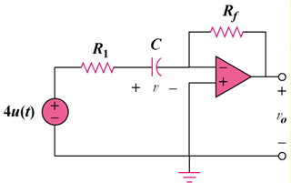

Figure 7.138
For Prob. 7.73.

Solution

+

v₁

R₁

+

R_{f}

C

v₂
+

v

v₁

v₃

+

v_{o}

Consider the circuit below.

At node 2,
(1)

At node 3,
(2)

But and . Hence, (1) becomes
or
which is similar to Eq. (7.42). Hence,
where and

From (2),
$\text{–}\text{6}e^{\text{-5t}}u(t) V$

